Do Swiss hunting regulations protect locally breeding woodcocks?
When do woodcocks depart Swiss forests?

Intro

Woodcocks are hunted also in France, and survival analysis and PVA showed that apparent survival probability is too low to maintain populations, but that predation is similar in a hunting-free reserve and a hunting area, suggesting that hunting is additive mortality (Duriez et al. 2005)
Juvenile survival is lower than adult survival (Tavecchia et al. 2002)
Survival probability is directly correlated with hunting pressure, both temporally and spatially (Péron et al. 2011).

In Spain, an area with more permitted hunting days had a lower survival than an adjacent area that was climatically similar but restricted hunting to 3 days per week (Prieto et al. 2019).

Methods
Data collection
[Pierre to fill in]

Data analysis
To estimate the likely timing of departure of woodcocks from the forest in the Swiss study area we utilized data from ringed individuals, and those equipped with either a VHF tag or a satellite transmitter. Because animals could only be recorded if they were caught or shot, or if the signal of their VHF transmitter was received, we estimated the timing of departure with a multi-event capture-recapture model (Genovart, Pradel, & Oro, 2012; Zúñiga et al., 2017) that accounted for uncertainty in the true state of the animal during weeks when it was not observed.

This model used weekly encounter occasions to estimate whether marked individuals were in one of four true states, namely 1) alive inside the study area, 2) dead inside the study area, or 3) alive or 4) dead outside the study area after migration. These true states were informed by the available data in five different observable ‘events’, which could either indicate that an individual was re-captured or recorded in the study area, whether transmitter signals were received from a live animal outside the study area, or whether the animal was found dead inside or outside of the study area. We included an event that individuals were ‘not recorded’, during which their true state was unknown.

The probability of an animal to be in any of the four latent true states given that it was observed in one of the five observation events was modelled based on the probability to receive data from or directly observe an animal, and the probability to find a dead animal once it died. The model estimated weekly survival, migration, and observation probabilities, where survival was assumed to be constant over the period analysed (August – December), while the probability to depart the study area from one week to the next (migration probability) was assumed to increase with increasing time. We chose a weekly interval for survival and migration estimation because it resembled the most sensible tradeoff between data resolution and administrative utility.
The probability to recover the carcass of a dead bird in each week was modelled as a function of whether it was inside or outside the study area, because the much higher observer density and reporting rate inside the study area made it more likely that dead birds would be recovered. The probability to observe a live individual was assumed to depend on the amount of observation effort in each week, and additionally on whether an individual was equipped with a transmitter, because the probability to receive data from a bird with transmitter was greater than the probability to observe or recapture a bird only equipped with a leg ring. Given that our data were accumulated over a time span of 13 years, we accounted for the possibility of temporal variation in survival and detection probabilities due to environmental influences by allowing survival and detection probabilities to vary in each year.
We used a Bayesian framework for inference and parameter estimation, with….. We used vague normally distributed priors for all other parameters, and conducted a prior sensitivity test to ensure that biologically plausible survival estimates resulted from our prior distributions, and that a different choice of priors did not affect our conclusions (Banner, Irvine, & Rodhouse, 2020). We fit the survival model in the program Nimble (de Valpine et al. 2016). We ran four Markov chains for 50,000 iterations each, discarded the first 25,000 iterations, and used every fourth iteration for inference. Convergence of the four chains for all monitored parameters was visually inspected using trace plots and tested using the Gelman-Rubin diagnostic (Brooks & Gelman, 1998).
We present posterior estimates with 95% credible intervals for the weekly migration probability. To facilitate interpretation, we extrapolated our weekly migration probabilities over the second half of the year (from late July to the end of December) and estimated what proportion of the local woodcock population would remain in the local study area at the beginning of each week. We derive the date when 95% of the local woodcock population has departed the study area as the date when hunting would expose only a minor fraction of the local population to hunting pressure. We also provide the estimated proportion of local woodcocks remaining in the study area for several key dates, namely the 15 September (beginning of hunting season by federal law, and in the cantons of Jura and Neuchatel), 1 October (beginning of hunting season in Bern and Valais), 15 October (beginning of hunting season in Fribourg, Ticino, and Vaud), and 15 November (by which time 95% of the annually reported hunting bag of woodcocks have usually been shot).

Results
We marked XXX woodcocks between 2005 and 2018, of which YY were recovered dead inside the study area and ZZ were recovered dead outside the study area. The last confirmed location when marked individuals were observed in the study area ranged from 1 Sept – 13 Dec with a median date of 23 November (SD= 12 days, Fig. 1).

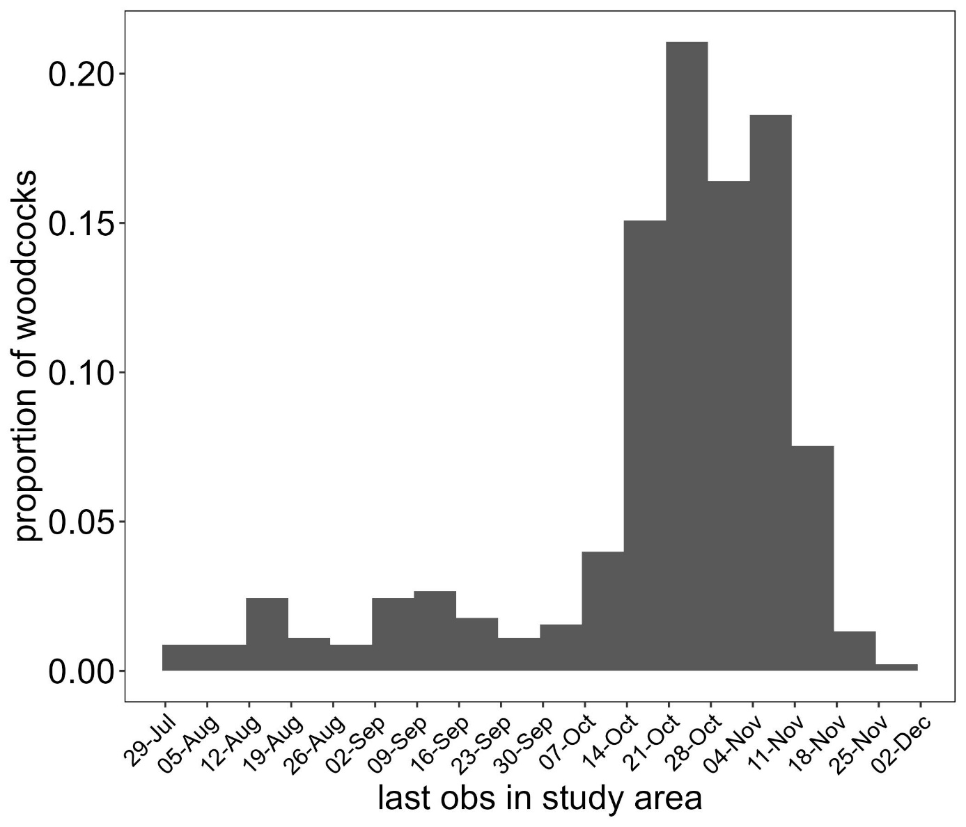
Figure 1. Proportion of individually marked woodcocks (n = 618) that were last observed in a given week of the year in the study area in a Swiss forest. Woodcocks were marked with rings or with transmitters and the last recorded observation of an individual depends on the effort and probability of detection and is therefore the earliest possible time when migration may have occurred.
Our model estimated that the probability to depart the study area increased with every week (b = zzz), and that 95% of the population had departed the study area by 30 November (95% credible interval 25 Nov – 5 Dec).
The proportion of the local population that remained inside the study area on 1 September was 94% (89 – 98%), on 1 October 86% (80 – 94%), on 15 October 74% (65 – 84%) and on 15 November 18% (11 – 27%; Fig. 1). Thus, the majority of local woodcocks were exposed to the majority of hunting pressure between 15 October and 15 November.

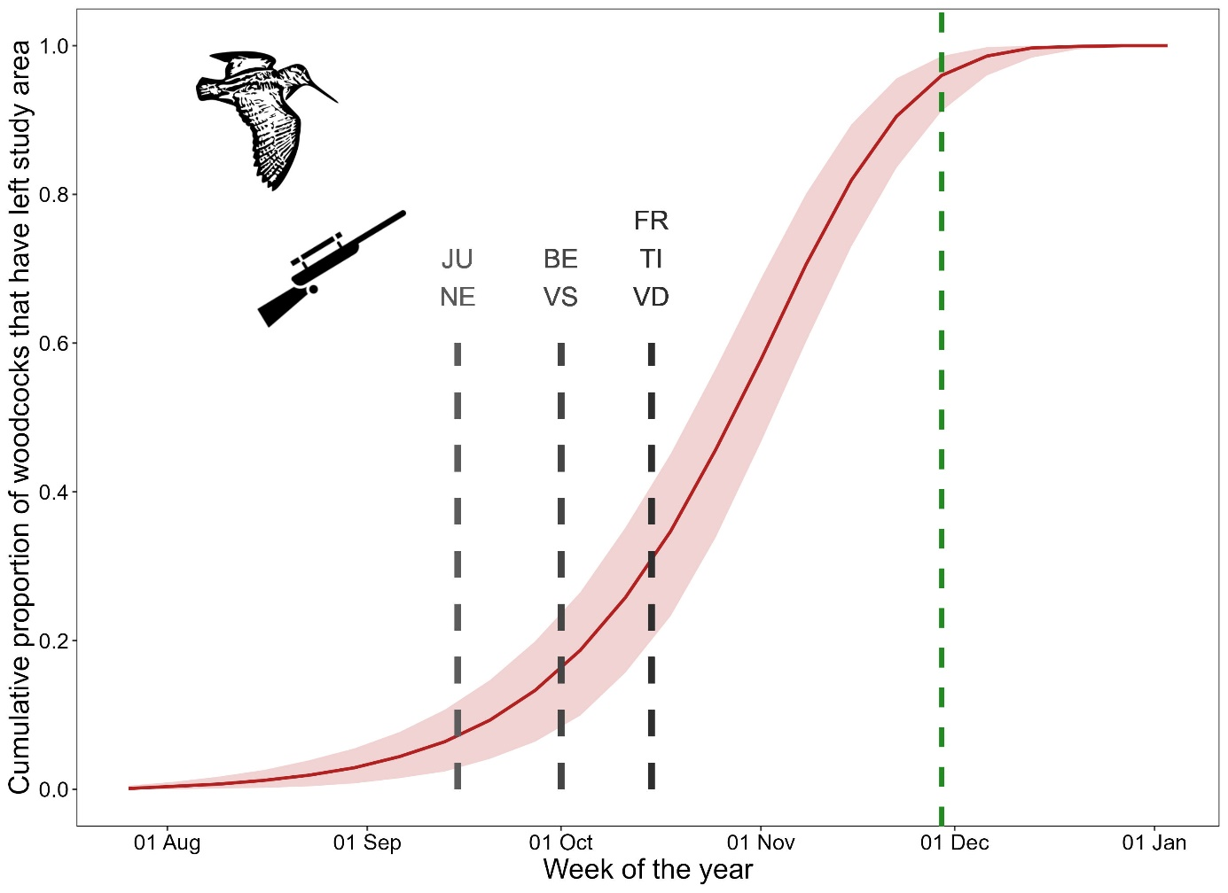

Figure 2. Predicted proportion of woodcocks that had departed our study area in a Swiss forest per given week of the year between 2005 and 2018 based on estimates of a multi-event model taking detection probability and state uncertainty into account. Dashed vertical lines indicate the beginning of the hunting seasons in different administrative regions (JU= Jura, NE= Neuchatel; BE= Bern, VS= Valais, FR = Fribourg, TI = Ticino, VD = Vaud), and the time when 95% of the local breeding population had departed the study area (green line, 30 November)

Discussion

Survival is positively associated with temperature in Spain, suggesting that lower

References
de Valpine, P., Turek, D., Paciorek, C.J., Anderson-Bergman, C., Lang, D.T., Bodik, R., 2016. Programming with models: writing statistical algorithms for general model structures with NIMBLE. J. Comput. Graph. Stat., 1-28.
Duriez, O., Eraud, C., Barbraud, C., Ferrand, Y., 2005. Factors affecting population dynamics of Eurasian woodcocks wintering in France: assessing the efficiency of a hunting-free reserve. Biol. Conserv. 122, 89-97.
Péron, G., Ferrand, Y., Gossmann, F., Bastat, C., Guenezan, M., Gimenez, O., 2011. Nonparametric spatial regression of survival probability: visualization of population sinks in Eurasian Woodcock. Ecology 92, 1672-1679.
Prieto, N., Tavecchia, G., Telletxea, I., Ibañez, R., Ansorregi, F., Galdos, A., Urruzola, A., Iriarte, I., Arizaga, J., 2019. Survival probabilities of wintering Eurasian Woodcocks Scolopax rusticola in northern Spain reveal a direct link with hunting regimes. J. Orn. 160, 329-336.
Tavecchia, G., Pradel, R., Gossmann, F., Bastat, C., Ferrand, Y., Lebreton, J.-D., 2002. Temporal variation in annual survival probability of the Eurasian woodcock Scolopax rusticola wintering in France. Wildl. Biol. 8, 21-30.

